BC Bee Atlas
Provincial Report - 2024 Baseline data
2025-12-27
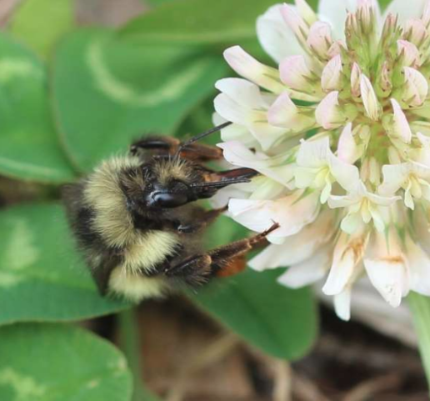

Prepared by:
Bonnie Zand and Kath Quayle
Native Bee Society of BC
bcnativebees@gmail.coment
Prepared for:
Native Bee Society of BC
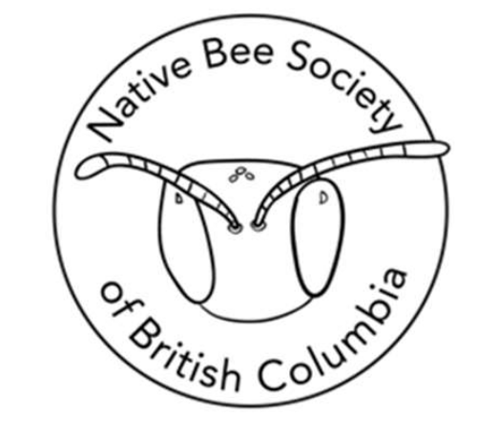

Acknowledgments
This report was prepared by the Native Bee Society of BC for the City of North Vancouver Engineering, Parks & Environment Department in partnership with the Oregon State University Extension Service Master Melittologist Program.
Project work was led by Bonnie Zand with contributions from Paula Cruise and Christine Thuring. Lincoln Best and Valerie Huff played an advisory role.
Richard Parker and Lianne Shyry from the City of North Vancouver oversaw the contract and provided permits and guidance on survey areas and priorities.
Volunteer training and collection protocols were provided, label printing and data management were provided by the OSU Master Melittologist Program.
Project report prepared by Bonnie Zand and Kath Quayle. Bonnie Zand provided species lists, data analysis and interpretation for the City of North Vancouver Data. Kath Quayle provided baseline data from the public record and bee-pant associations from iNaturalist. Specimen identifications were provided by Bonnie Zand.
The Oregon Bee Atlas and Master Melittologist Program provided training, protocols and data management
- Automated specimen data pipeline (Andony Melathopoulos, Lincoln Best and Myles Scholz, OSU)
- Specimen data production (Cassidy Carpenter and Anne Watts, OSU)
- Label production (Cassidy Carpenter and Anne Watts, OSU)
INat and specimen data management and curation (Lincoln Best, OSU) Data collection, specimen prep and labelling were provided by volunteers from the OSU Master Melittologist Program:
- AC Quinn
- Jane Lakes
- Bonnie Zand
- Elizabeth Hudgins
- Jackson MacPherson
- Paula Cruise
- Lila Herzog
- Christine Bickson
- Kath Quayle
- Kristen Penhall
Cover Photo: Bombus flavifrons: Yellow-fronted bumble bee. © Lori Weidenhammer All other photos by Bonnie Zand

Table of Contents
Prepared by: 1
Prepared for: 1
Acknowledgements 2
Table of contents 3
Executive Summary 3
Description of project 3
BC Bee Atlas Survey Methods 4
BC Bee Atlas Survey Results 4

Quarto enables you to weave together content and executable code into a finished document. To learn more about Quarto see https://quarto.org.

Executive Summary
Over the summer of 2024 the Native Bee Society of BC, in collaboration with the OSU Master Melittologists, surveyed for bees in the City of North Vancouver. Over 10 survey days 175 specimens from five families, 14 genera and 43 species were collected from 36 different plant species. One species at risk, Bombus flavidus, was observed, as well as nine non- native species. Previous to these surveys, only 13 species were in the publicly available record. A species checklist is provided, as well as details on plant use by different bee families.

Description of project
The BC Bee Atlas provided native bee survey services to the City of North Vancouver over the summer of 2024, under contract with the City of North Vancouver Engineering, Parks & Environment Department. Surveys were intended to provide baseline data on native bee diversity and plant use to the City of North Vancouver, as well as a preliminary species list to guide ongoing pollinator conservation efforts. A specific focus of the project was on a City of North Vancouver pilot project to reduce mowing in areas of Grand Boulevard Park. Without baseline data, determining the possible effects of habitat modification is difficult. In addition, without a species-level understanding of the fauna using City of North Vancouver parks, planting plans and modifications may inadvertently support common or introduced species rather than rare and vulnerable species. The production of a species list is intended to provide the City of North Vancouver with specific information on the rare, common and introduced species using the park and the plants supporting those species.

BC Bee Atlas Survey Methods
Surveys were conducted by volunteers trained by the Oregon State University Master Melittologist Program, following methods outlined by Best et al. (2022). Volunteers hand- netted bees from flowers within City of North Vancouver Parks. Bee specimens were retained, pinned, labelled, and submitted to the BC Bee Atlas for identification. Flowers bees were collected on were photographically documented using the citizen science platform iNaturalist, producing bee-plant association records. All the bee specimens collected from a single species of plant by a volunteer on a single day comprised one sample event.

BC Bee Atlas Survey Results
year | Month | # of days of survey | # of speciments collected | # of species documented
2.02e+03 | Jun | 1 | 1 | 1
2.02e+03 | Aug | 1 | 2 | 1
2.02e+03 | Mar | 1 | 2 | 1
2.02e+03 | Apr | 5 | 27 | 5
2.02e+03 | May | 14 | 69 | 14
2.02e+03 | Jun | 15 | 106 | 29
2.02e+03 | Jul | 16 | 131 | 27
2.02e+03 | Aug | 11 | 91 | 19
2.02e+03 | Sep | 12 | 43 | 10
2.02e+03 | Oct | 2 | 9 | 3
2.02e+03 | Mar | 5 | 14 | 4
2.02e+03 | Apr | 10 | 25 | 6
2.02e+03 | May | 13 | 56 | 11
2.02e+03 | Jun | 15 | 110 | 24
2.02e+03 | Jul | 21 | 114 | 30
2.02e+03 | Aug | 19 | 269 | 45
2.02e+03 | Sep | 14 | 103 | 21
2.02e+03 | Oct | 3 | 10 | 7
2.02e+03 | Mar | 2 | 3 | 1
2.02e+03 | Apr | 5 | 18 | 4
2.02e+03 | May | 19 | 269 | 31
2.02e+03 | Jun | 20 | 437 | 55
2.02e+03 | Jul | 18 | 218 | 33
2.02e+03 | Aug | 13 | 86 | 20
2.02e+03 | Sep | 3 | 12 | 5
2.02e+03 | Mar | 6 | 10 | 4
2.02e+03 | Apr | 12 | 53 | 13
2.02e+03 | May | 19 | 234 | 34
2.02e+03 | Jun | 20 | 695 | 82
2.02e+03 | Jul | 23 | 477 | 80
2.02e+03 | Aug | 20 | 677 | 52
2.02e+03 | Sep | 13 | 318 | 38
2.02e+03 | Oct | 1 | 2 | 2
2.02e+03 | Nov | 1 | 1 | 1

Document prepared with ❤️ and Quarto
Last updated Sat Dec 27 14:37:06 2025

